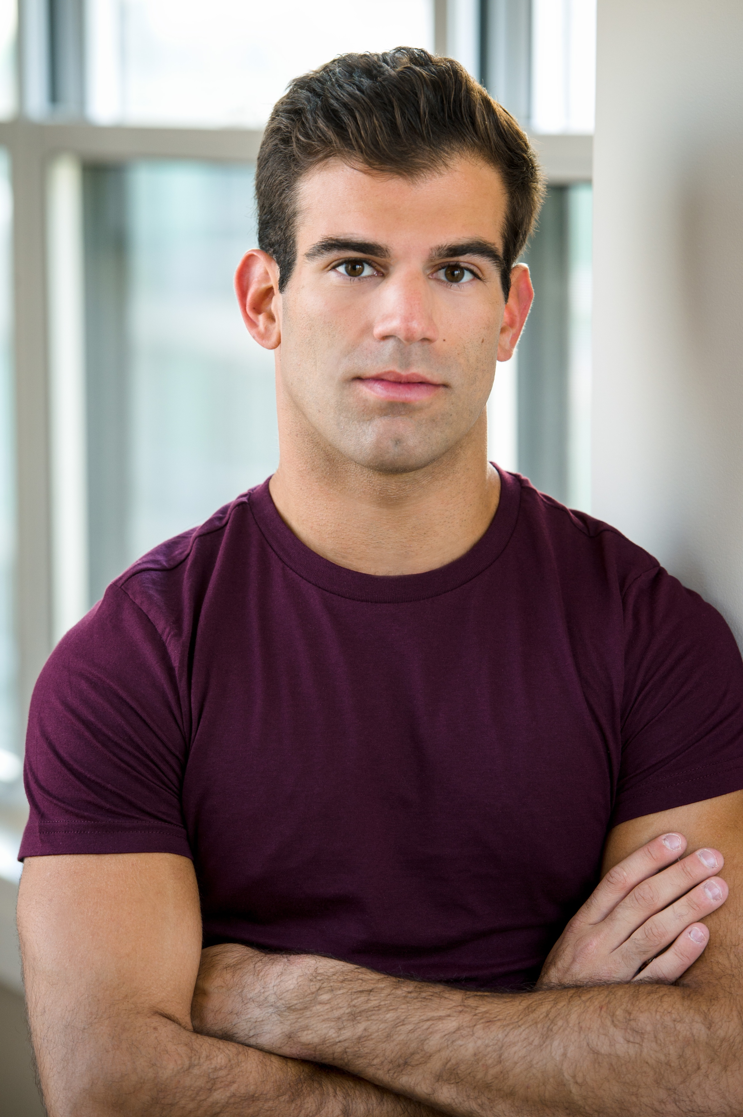
Adam Mandala
AEA
adammandala.com
(201) 247-1416 Height: 5’ 8”
adammandala@aol.com Weight: 155lbs.

Regional
Shrek the Musical Mad Hatter/Ensemble Walnut Street Theatre (WST) Dir. Glenn Casale
Legally Blonde Carlos/Ensemble Riverside Theatre & WST Dir./Choreo. Richard Stafford
Young Frankenstein Ensemble Walnut Street Theatre Dir. Chuck Abbott
Mamma Mia Ensemble Riverside Theatre & WST Dir./Choreo. Richard Stafford
Evita Ensemble Riverside Theatre Dir. Marcia Milgrom Dodge
Newsies Spot Conlon/Henry Arts Center of Coastal Carolina Dir. Mark Martino
Evita Ensemble Westport Country Playhouse Choreo. Eric Santagata
Best Little Whorehouse… Aggie Boy Finger Lakes MTF Dir. Parker Esse
West Side Story Pepe Finger Lakes MTF Dir. Parker Esse
On the Town Ensemble Finger Lakes MTF Dir. Brett Smock
How to Succeed… External u/s Walnut Street Theatre Dir. Casey Hushion
Chicago Dancer Maples Rep Theatre Dir. Brandon McShaffrey
South Pacific Henri Maples Rep Theatre Dir. Todd Davidson

Cruise
Grease Ensemble/Sonny u/s Royal Caribbean Int’l Dir. Tony Edge
New York City
How Alfo Learned to Love Tony NY Int’l Fringe Festival
Television
“30 Rock“ Featured Role NBC
“iCarly” Featured Dancer Nickelodeon

Educational
Anything Goes Moonface Martin Temple University Dir. Peter Reynolds
Hair Woof Temple University Dir. Brandon McShaffrey
Oklahoma! Ensemble Temple University Dir. Peter Reynolds
Spelling Bee Chip PPAS, NYC Dir. Mala Tsantiles
Emma Harry PPAS, NYC Dir. Tamara Fisch

Training
BA in Musical Theater Temple University, Philadelphia
Dance (Theatre, Jazz, Tap, Ballet) Broadway Dance Center
Vocal James Donegan (7 Yrs)
The Broadway Connection Actors Connection, NYC
Acting/Improv Lane Napper, NYC
Acting/Singing/Dancing TADA! Youth Theater, NYC

Special Skills
Aerial training (C5 certified), minor piano training, reads music, knows the choreography to Britney’s “Toxic” and “Slave 4 U” by heart

